* How to check a variable’s type?

+ Use function: type

* Print(type(‘variable’))
* Examble:

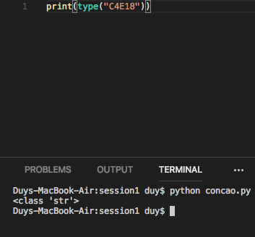

* In what cases, you will get ***SyntaxError*** from the compiler telling you that some of your variables have **invalid names**? Can you give 3 different examples of **invalid names**?

+ Variable’s name doesn’t start with a letter or an underscore

* 69xyz = “abcd”

+ Variable’s name contains an illegal character

* $ = “dollar”

+ Variable’s name is one of the Python’s keywords

* is = “la”